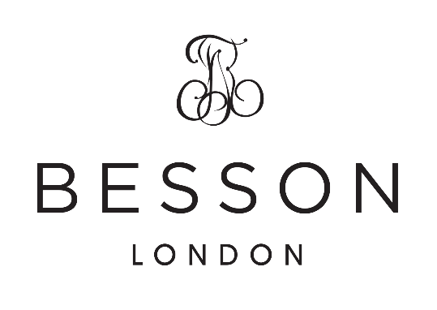


Besson Slow Melody Contest
Entry Form – send completed form to:
qbandsecretary@gmail.com

Contestant Name
QBA affiliated band
Entry Fee $25.00 | Payable to:  Account Name: Queensland Band Association  BSB: 124 021  Account No: 1000 6159  Reference: Slow Melody
Band Secretary Name:
Band Secretary Signature:

Please remember: Band Uniform worn for performance/s
One soloist per association
Slow Melody time limit – 5 minutes
Piano accompaniment
APRA form to be attached to copy of music.

